Mathematical Formula

🌟 Definition
# Source: AI Source: Provided by: [Data Path: Persons Table -> ID Column: 1, Name_En Column: Motasem Essam] -> From: [ChatGPT] on [5/29/2026]
A mathematical formula is a precise rule or expression written using mathematical symbols that shows a relationship between quantities or variables.
It is a compact way to represent a mathematical idea or relationship.

🎯 Purpose of a Formula
# Source: AI Source: Provided by: [Data Path: Persons Table -> ID Column: 1, Name_En Column: Motasem Essam] -> From: [ChatGPT] on [5/29/2026]
- To represent relationships between quantities clearly
- To simplify calculations and problem-solving
- To describe patterns in mathematics and science
- To model real-world situations
- To provide reusable mathematical rules

📚 Key Characteristics
# Source: AI Source: Provided by: [Data Path: Persons Table -> ID Column: 1, Name_En Column: Motasem Essam] -> From: [ChatGPT] on [5/29/2026]
A mathematical formula is:
- Written using symbols and variables
- Concise and precise
- Based on mathematical rules
- Used for calculation or representation
- Applicable in many problems

🧩 Structure of a Formula
# Source: AI Source: Provided by: [Data Path: Persons Table -> ID Column: 1, Name_En Column: Motasem Essam] -> From: [ChatGPT] on [5/29/2026]
A formula usually contains:
- Variables (unknown or changing values)
- Constants (fixed values)
- Mathematical operations (+, −, ×, ÷, powers, etc.)
- An equality or relationship sign (=)

✏️ Examples of Mathematical Formulas

1. Area of a Rectangle
# Source: AI Source: Provided by: [Data Path: Persons Table -> ID Column: 1, Name_En Column: Motasem Essam] -> From: [ChatGPT] on [5/29/2026]
$$A=l×w$$

2. Area of a Circle
# Source: AI Source: Provided by: [Data Path: Persons Table -> ID Column: 1, Name_En Column: Motasem Essam] -> From: [ChatGPT] on [5/29/2026]
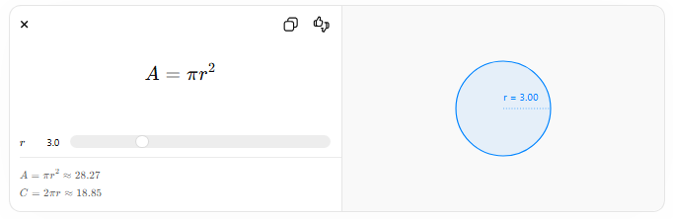
$$A=πr^{2}$$
$$r$$
$$A=πr^{2}≈28.27$$
$$C=2πr≈18.85$$
r = 3.00

3. Pythagorean Formula
# Source: AI Source: Provided by: [Data Path: Persons Table -> ID Column: 1, Name_En Column: Motasem Essam] -> From: [ChatGPT] on [5/29/2026]
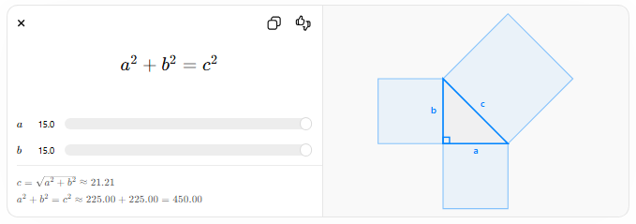
$$a^{2}+b^{2}=c^{2}$$
$$a$$
$$b$$
$$c=\sqrt{a^{2}+b^{2}}≈21.21$$
$$a^{2}+b^{2}=c^{2}≈225.00+225.00=450.00$$

4. Quadratic Formula
# Source: AI Source: Provided by: [Data Path: Persons Table -> ID Column: 1, Name_En Column: Motasem Essam] -> From: [ChatGPT] on [5/29/2026]
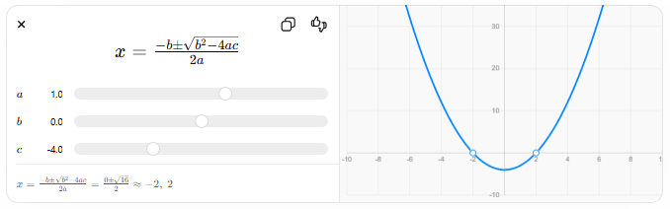
$$x=\frac{-b±\sqrt{b^{2}-4ac}}{2a}$$
$$a$$
$$b$$
$$c$$
$$x=\frac{-b±\sqrt{b^{2}-4ac}}{2a}=\frac{0±\sqrt{16}}{2}≈-2, 2$$

5. Newton’s Second Law
# Source: AI Source: Provided by: [Data Path: Persons Table -> ID Column: 1, Name_En Column: Motasem Essam] -> From: [ChatGPT] on [5/29/2026]
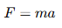
$$F=ma$$

🔗 Relationship to Other Concepts
# Source: AI Source: Provided by: [Data Path: Persons Table -> ID Column: 1, Name_En Column: Motasem Essam] -> From: [ChatGPT] on [5/29/2026]
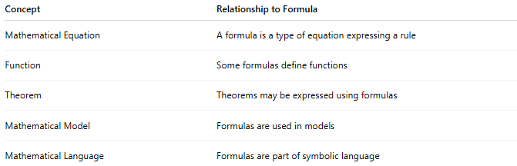
Concept | Relationship to Formula
Mathematical Equation | A formula is a type of equation expressing a rule
Function | Some formulas define functions
Theorem | Theorems may be expressed using formulas
Mathematical Model | Formulas are used in models
Mathematical Language | Formulas are part of symbolic language

📖 Formula vs Equation vs Theorem
# Source: AI Source: Provided by: [Data Path: Persons Table -> ID Column: 1, Name_En Column: Motasem Essam] -> From: [ChatGPT] on [5/29/2026]
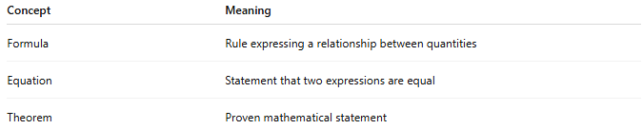
Concept | Meaning
Formula | Rule expressing a relationship between quantities
Equation | Statement that two expressions are equal
Theorem | Proven mathematical statement

🧠 Simple Analogy
# Source: AI Source: Provided by: [Data Path: Persons Table -> ID Column: 1, Name_En Column: Motasem Essam] -> From: [ChatGPT] on [5/29/2026]
A mathematical formula is like a recipe in cooking:
- Ingredients = variables
- Steps = operations
- Final dish = result

🧭 Summary
# Source: AI Source: Provided by: [Data Path: Persons Table -> ID Column: 1, Name_En Column: Motasem Essam] -> From: [ChatGPT] on [5/29/2026]
A mathematical formula is a symbolic expression that describes a relationship between quantities or variables. It is used to calculate, represent, and understand mathematical and real-world relationships in a simple and precise way.

